## Output of MBA Salaries Analysis

### Pratyusha Maiti

#### Email: [pratyusha.maiti@gmail.com](mailto:pratyusha.maiti@gmail.com)

#### Jadavpur University

> library(psych)

> describe(mba)

vars n mean sd median trimmed mad min max range skew kurtosis se

age 1 274 27.36 3.71 27 26.76 2.97 22 48 26 2.16 6.45 0.22

sex 2 274 1.25 0.43 1 1.19 0.00 1 2 1 1.16 -0.66 0.03

gmat_tot 3 274 619.45 57.54 620 618.86 59.30 450 790 340 -0.01 0.06 3.48

gmat_qpc 4 274 80.64 14.87 83 82.31 14.83 28 99 71 -0.92 0.30 0.90

gmat_vpc 5 274 78.32 16.86 81 80.33 14.83 16 99 83 -1.04 0.74 1.02

gmat_tpc 6 274 84.20 14.02 87 86.12 11.86 0 99 99 -2.28 9.02 0.85

s_avg 7 274 3.03 0.38 3 3.03 0.44 2 4 2 -0.06 -0.38 0.02

f_avg 8 274 3.06 0.53 3 3.09 0.37 0 4 4 -2.08 10.85 0.03

quarter 9 274 2.48 1.11 2 2.47 1.48 1 4 3 0.02 -1.35 0.07

work_yrs 10 274 3.87 3.23 3 3.29 1.48 0 22 22 2.78 9.80 0.20

frstlang 11 274 1.12 0.32 1 1.02 0.00 1 2 1 2.37 3.65 0.02

salary 12 274 39025.69 50951.56 999 33607.86 1481.12 0 220000 220000 0.70 -1.05 3078.10

satis 13 274 172.18 371.61 6 91.50 1.48 1 998 997 1.77 1.13 22.45

> par(mfrow = c(2,2))

> #Individual variable visualisation

> boxplot(gmat_tot, horizontal = TRUE, xlab = "GMAT Total score")

> boxplot(gmat_tpc, horizontal = TRUE, xlab = "Overall GMAT Percentage")

> boxplot(s_avg, horizontal = TRUE, xlab = "Spring MBA Average")

> boxplot(f_avg, horizontal = TRUE, xlab = "Fall MBA Average")

> par(mfrow = c(1,1))

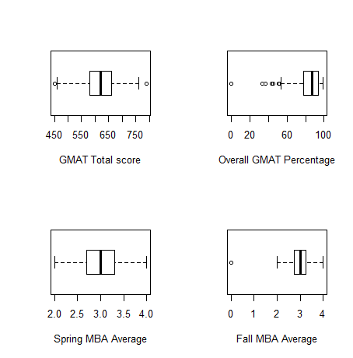

> par(mfrow = c(2,1))

>

> #Visualise starting salary with respect to various factors

> boxplot(salary~sex, horizontal = TRUE, xlab = "Starting salary", ylab = "Gender", main = "Gender vs Starting Salary")

> boxplot(salary~frstlang, horizontal = TRUE, xlab = "Starting salary", ylab = "First Language", main = "First Language vs Starting Salary")

> par(mfrow = c(1,1))

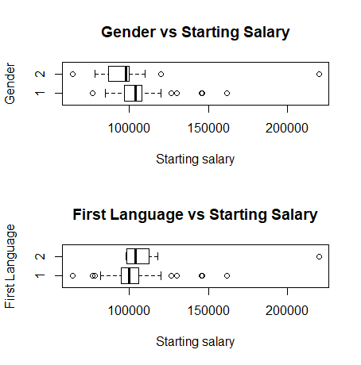

> library(ggplot2)

> ggplot(revised_mba, aes(x=gmat_tot, y=salary)) + geom_jitter() + facet_grid(.~sex)

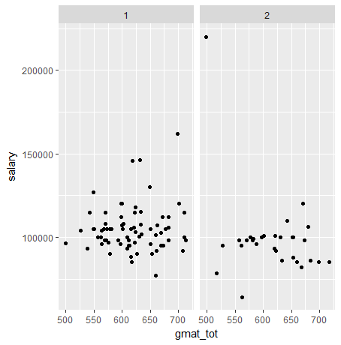

> ggplot(revised_mba, aes(x=gmat_tot, y=salary)) + geom_jitter() + facet_grid(.~frstlang)

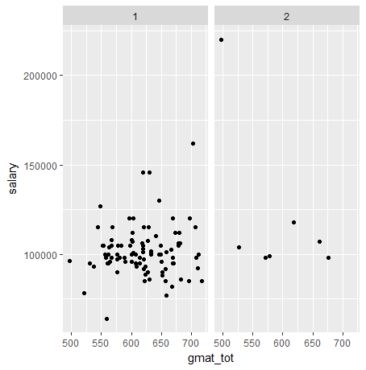

> ggplot(revised_mba, aes(x=age, y=salary)) + geom_jitter() + facet_grid(.~sex)

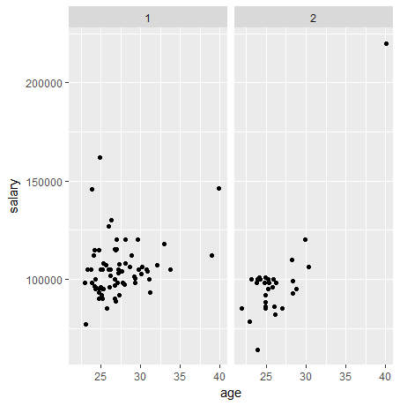

> ggplot(revised_mba, aes(x=work_yrs, y=salary)) + geom_jitter() + facet_grid(.~sex)

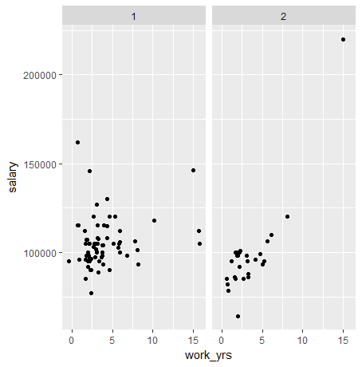

> qplot(gmat_tot, salary,

+ main="GMAT Total vs Starting salary",

+ xlab="GMAT Total score", ylab="Starting salary",

+ color = work_yrs)

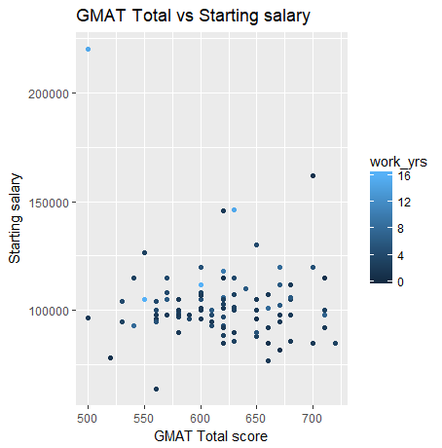

> qplot(gmat_tot, salary,

+ main="GMAT Total vs Starting salary",

+ xlab="GMAT Total score", ylab="Starting salary",

+ color = satis)

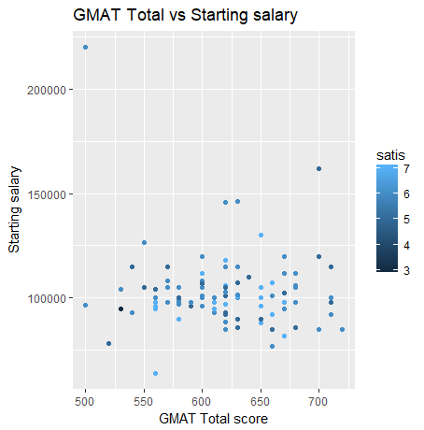

> qplot(gmat_tot,gmat_tpc,

+ main="GMAT Total vs GMAT Percentile",

+ xlab="GMAT Total", ylab="GMAT Percentile",

+ color = salary)

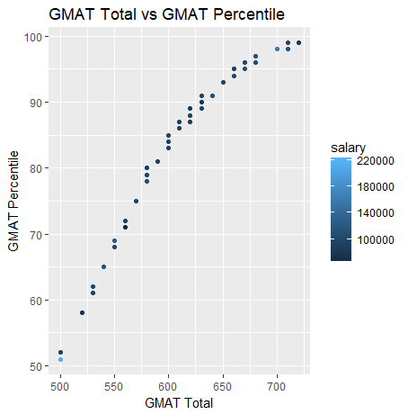

> study <- cor(revised_mba)

> study

age sex gmat_tot gmat_qpc gmat_vpc gmat_tpc s_avg f_avg quarter

age 1.00000000 -0.14352927 -0.07871678 -0.165039057 0.01799420 -0.09609156 0.15654954 -0.21699191 -0.12568145

sex -0.14352927 1.00000000 -0.01955548 -0.147099027 0.05341428 -0.04686981 0.08079985 0.16572186 -0.02139041

gmat_tot -0.07871678 -0.01955548 1.00000000 0.666382266 0.78038546 0.96680810 0.17198874 0.12246257 -0.10578964

gmat_qpc -0.16503906 -0.14709903 0.66638227 1.000000000 0.09466541 0.65865003 0.01547166 0.09841887 0.01264835

gmat_vpc 0.01799420 0.05341428 0.78038546 0.094665411 1.00000000 0.78443167 0.15865101 0.02290167 -0.12862079

gmat_tpc -0.09609156 -0.04686981 0.96680810 0.658650025 0.78443167 1.00000000 0.13938500 0.07051391 -0.09955033

s_avg 0.15654954 0.08079985 0.17198874 0.015471662 0.15865101 0.13938500 1.00000000 0.44590413 -0.84038355

f_avg -0.21699191 0.16572186 0.12246257 0.098418869 0.02290167 0.07051391 0.44590413 1.00000000 -0.43144819

quarter -0.12568145 -0.02139041 -0.10578964 0.012648346 -0.12862079 -0.09955033 -0.84038355 -0.43144819 1.00000000

work_yrs 0.88052470 -0.09233003 -0.12280018 -0.182701263 -0.02812182 -0.13246963 0.16328236 -0.21633018 -0.12896722

frstlang 0.35026743 0.07512009 -0.13164323 0.014198516 -0.21835333 -0.16437561 -0.13788905 -0.05061394 0.10955726

salary 0.49964284 -0.16628869 -0.09067141 0.014141299 -0.13743230 -0.13201783 0.10173175 -0.10603897 -0.12848526

satis 0.10832308 -0.09199534 0.06474206 -0.003984632 0.14863481 0.11630842 -0.14356557 -0.11773304 0.22511985

work_yrs frstlang salary satis

age 0.88052470 0.35026743 0.49964284 0.108323083

sex -0.09233003 0.07512009 -0.16628869 -0.091995338

gmat_tot -0.12280018 -0.13164323 -0.09067141 0.064742057

gmat_qpc -0.18270126 0.01419852 0.01414130 -0.003984632

gmat_vpc -0.02812182 -0.21835333 -0.13743230 0.148634805

gmat_tpc -0.13246963 -0.16437561 -0.13201783 0.116308417

s_avg 0.16328236 -0.13788905 0.10173175 -0.143565573

f_avg -0.21633018 -0.05061394 -0.10603897 -0.117733043

quarter -0.12896722 0.10955726 -0.12848526 0.225119851

work_yrs 1.00000000 0.19627277 0.45466634 0.062999256

frstlang 0.19627277 1.00000000 0.26701953 0.089834769

salary 0.45466634 0.26701953 1.00000000 -0.040050600

satis 0.06299926 0.08983477 -0.04005060 1.000000000

> corrplot.mixed(study,

+ upper = "circle",

+ lower = "ellipse",

+ col = colorpanel(50, "red", "lightblue", "blue"),

+ tl.pos = "lt")

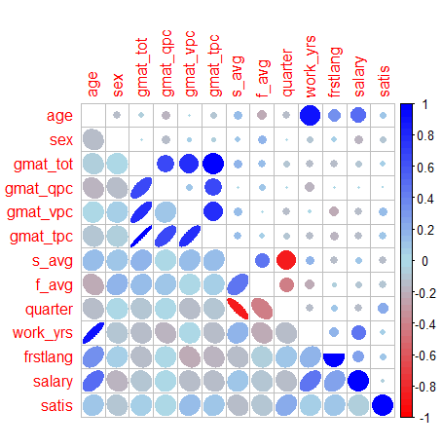

> #Variance matrix

> var(revised_mba)

age sex gmat_tot gmat_qpc gmat_vpc gmat_tpc s_avg f_avg

age 10.7045498 -2.164477e-01 -1.305445e+01 -7.22796497 9.505045e-01 -3.460213e+00 0.19385875 -3.462517e-01

sex -0.2164477 2.124500e-01 -4.568818e-01 -0.90757662 3.974872e-01 -2.377689e-01 0.01409575 3.725395e-02

gmat_tot -13.0544451 -4.568818e-01 2.569294e+03 452.14258519 6.386360e+02 5.393623e+02 3.29956215 3.027432e+00

gmat_qpc -7.2279650 -9.075766e-01 4.521426e+02 179.18027794 2.045850e+01 9.703607e+01 0.07838473 6.425214e-01

gmat_vpc 0.9505045 3.974872e-01 6.386360e+02 20.45849990 2.606602e+02 1.393882e+02 0.96945936 1.803303e-01

gmat_tpc -3.4602132 -2.377689e-01 5.393623e+02 97.03607462 1.393882e+02 1.211342e+02 0.58062916 3.785056e-01

s_avg 0.1938587 1.409575e-02 3.299562e+00 0.07838473 9.694594e-01 5.806292e-01 0.14325138 8.231046e-02

f_avg -0.3462517 3.725395e-02 3.027432e+00 0.64252142 1.803303e-01 3.785056e-01 0.08231046 2.378638e-01

quarter -0.4604988 -1.104131e-02 -6.005140e+00 0.18960594 -2.325528e+00 -1.227013e+00 -0.35620503 -2.356492e-01

work_yrs 8.6728536 -1.281173e-01 -1.873882e+01 -7.36245955 -1.366838e+00 -4.389206e+00 0.18604797 -3.176271e-01

frstlang 0.2898344 8.756901e-03 -1.687607e+00 0.04806777 -8.915858e-01 -4.575481e-01 -0.01319912 -6.243099e-03

salary 29210.5193223 -1.369577e+03 -8.212449e+04 3382.43784504 -3.964803e+04 -2.596339e+04 688.02042071 -9.241129e+02

satis 0.2776509 -3.321911e-02 2.570912e+00 -0.04178565 1.879973e+00 1.002856e+00 -0.04256901 -4.498382e-02

quarter work_yrs frstlang salary satis

age -4.604988e-01 8.6728536 2.898344e-01 2.921052e+04 0.27765087

sex -1.104131e-02 -0.1281173 8.756901e-03 -1.369577e+03 -0.03321911

gmat_tot -6.005140e+00 -18.7388159 -1.687607e+00 -8.212449e+04 2.57091186

gmat_qpc 1.896059e-01 -7.3624595 4.806777e-02 3.382438e+03 -0.04178565

gmat_vpc -2.325528e+00 -1.3668380 -8.915858e-01 -3.964803e+04 1.87997335

gmat_tpc -1.227013e+00 -4.3892062 -4.575481e-01 -2.596339e+04 1.00285551

s_avg -3.562050e-01 0.1860480 -1.319912e-02 6.880204e+02 -0.04256901

f_avg -2.356492e-01 -0.3176271 -6.243099e-03 -9.241129e+02 -0.04498382

quarter 1.254140e+00 -0.4347992 3.102989e-02 -2.571117e+03 0.19750619

work_yrs -4.347992e-01 9.0630116 1.494384e-01 2.445820e+04 0.14858176

frstlang 3.102989e-02 0.1494384 6.396345e-02 1.206714e+03 0.01779935

salary -2.571117e+03 24458.1995050 1.206714e+03 3.192940e+08 -560.65829050

satis 1.975062e-01 0.1485818 1.779935e-02 -5.606583e+02 0.61374453

> var(mba)

age sex gmat_tot gmat_qpc gmat_vpc gmat_tpc s_avg f_avg

age 1.376904e+01 -4.513248e-02 -3.115879e+01 -1.192655e+01 -2.7636427 -8.8399775 0.21168739 -0.03399348

sex -4.513248e-02 1.872677e-01 -1.328841e+00 -1.053769e+00 0.5463758 -0.0490896 0.02096227 0.02082698

gmat_tot -3.115879e+01 -1.328841e+00 3.310688e+03 6.200233e+02 726.0006417 683.9910698 2.48025721 3.15468838

gmat_qpc -1.192655e+01 -1.053769e+00 6.200233e+02 2.210731e+02 38.1482581 135.7996845 -0.16912329 0.57538542

gmat_vpc -2.763643e+00 5.463758e-01 7.260006e+02 3.814826e+01 284.2481217 157.4932488 1.31357023 0.67207000

gmat_tpc -8.839978e+00 -4.908960e-02 6.839911e+02 1.357997e+02 157.4932488 196.6057057 0.62710008 0.58698618

s_avg 2.116874e-01 2.096227e-02 2.480257e+00 -1.691233e-01 1.3135702 0.6271001 0.14521760 0.11016898

f_avg -3.399348e-02 2.082698e-02 3.154688e+00 5.753854e-01 0.6720700 0.5869862 0.11016898 0.27567237

quarter -2.045935e-01 -6.414267e-02 -5.891153e+00 6.001979e-01 -3.2676666 -1.2923719 -0.32237213 -0.26080880

work_yrs 1.029494e+01 -1.580172e-02 -3.391634e+01 -1.137186e+01 -3.6181653 -7.8575172 0.15926392 -0.06628700

frstlang 6.796610e-02 2.138980e-04 -2.499933e+00 6.646346e-01 -2.1145691 -0.4663244 -0.01671372 -0.00626026

salary -1.183042e+04 1.518264e+03 -1.611600e+05 -3.335823e+04 -5273.8523836 3522.7500067 2831.60098580 787.65597177

satis -1.763499e+02 -8.780808e+00 1.765263e+03 3.348371e+02 392.3562739 484.2466779 -4.62884495 2.12532927

quarter work_yrs frstlang salary satis

age -2.045935e-01 10.29493864 6.796610e-02 -1.183042e+04 -1.763499e+02

sex -6.414267e-02 -0.01580172 2.138980e-04 1.518264e+03 -8.780808e+00

gmat_tot -5.891153e+00 -33.91633914 -2.499933e+00 -1.611600e+05 1.765263e+03

gmat_qpc 6.001979e-01 -11.37186171 6.646346e-01 -3.335823e+04 3.348371e+02

gmat_vpc -3.267667e+00 -3.61816529 -2.114569e+00 -5.273852e+03 3.923563e+02

gmat_tpc -1.292372e+00 -7.85751718 -4.663244e-01 3.522750e+03 4.842467e+02

s_avg -3.223721e-01 0.15926392 -1.671372e-02 2.831601e+03 -4.628845e+00

f_avg -2.608088e-01 -0.06628700 -6.260260e-03 7.876560e+02 2.125329e+00

quarter 1.232119e+00 -0.30866822 3.553381e-02 -9.296214e+03 -5.227133e-03

work_yrs -3.086682e-01 10.44882490 -2.898318e-02 1.486147e+03 -1.312408e+02

frstlang 3.553381e-02 -0.02898318 1.035266e-01 -1.419586e+03 9.484532e+00

salary -9.296214e+03 1486.14704152 -1.419586e+03 2.596062e+09 -6.347115e+06

satis -5.227133e-03 -131.24080907 9.484532e+00 -6.347115e+06 1.380974e+05

> #Covariance matrix

> cov(revised_mba)

age sex gmat_tot gmat_qpc gmat_vpc gmat_tpc s_avg f_avg

age 10.7045498 -2.164477e-01 -1.305445e+01 -7.22796497 9.505045e-01 -3.460213e+00 0.19385875 -3.462517e-01

sex -0.2164477 2.124500e-01 -4.568818e-01 -0.90757662 3.974872e-01 -2.377689e-01 0.01409575 3.725395e-02

gmat_tot -13.0544451 -4.568818e-01 2.569294e+03 452.14258519 6.386360e+02 5.393623e+02 3.29956215 3.027432e+00

gmat_qpc -7.2279650 -9.075766e-01 4.521426e+02 179.18027794 2.045850e+01 9.703607e+01 0.07838473 6.425214e-01

gmat_vpc 0.9505045 3.974872e-01 6.386360e+02 20.45849990 2.606602e+02 1.393882e+02 0.96945936 1.803303e-01

gmat_tpc -3.4602132 -2.377689e-01 5.393623e+02 97.03607462 1.393882e+02 1.211342e+02 0.58062916 3.785056e-01

s_avg 0.1938587 1.409575e-02 3.299562e+00 0.07838473 9.694594e-01 5.806292e-01 0.14325138 8.231046e-02

f_avg -0.3462517 3.725395e-02 3.027432e+00 0.64252142 1.803303e-01 3.785056e-01 0.08231046 2.378638e-01

quarter -0.4604988 -1.104131e-02 -6.005140e+00 0.18960594 -2.325528e+00 -1.227013e+00 -0.35620503 -2.356492e-01

work_yrs 8.6728536 -1.281173e-01 -1.873882e+01 -7.36245955 -1.366838e+00 -4.389206e+00 0.18604797 -3.176271e-01

frstlang 0.2898344 8.756901e-03 -1.687607e+00 0.04806777 -8.915858e-01 -4.575481e-01 -0.01319912 -6.243099e-03

salary 29210.5193223 -1.369577e+03 -8.212449e+04 3382.43784504 -3.964803e+04 -2.596339e+04 688.02042071 -9.241129e+02

satis 0.2776509 -3.321911e-02 2.570912e+00 -0.04178565 1.879973e+00 1.002856e+00 -0.04256901 -4.498382e-02

quarter work_yrs frstlang salary satis

age -4.604988e-01 8.6728536 2.898344e-01 2.921052e+04 0.27765087

sex -1.104131e-02 -0.1281173 8.756901e-03 -1.369577e+03 -0.03321911

gmat_tot -6.005140e+00 -18.7388159 -1.687607e+00 -8.212449e+04 2.57091186

gmat_qpc 1.896059e-01 -7.3624595 4.806777e-02 3.382438e+03 -0.04178565

gmat_vpc -2.325528e+00 -1.3668380 -8.915858e-01 -3.964803e+04 1.87997335

gmat_tpc -1.227013e+00 -4.3892062 -4.575481e-01 -2.596339e+04 1.00285551

s_avg -3.562050e-01 0.1860480 -1.319912e-02 6.880204e+02 -0.04256901

f_avg -2.356492e-01 -0.3176271 -6.243099e-03 -9.241129e+02 -0.04498382

quarter 1.254140e+00 -0.4347992 3.102989e-02 -2.571117e+03 0.19750619

work_yrs -4.347992e-01 9.0630116 1.494384e-01 2.445820e+04 0.14858176

frstlang 3.102989e-02 0.1494384 6.396345e-02 1.206714e+03 0.01779935

salary -2.571117e+03 24458.1995050 1.206714e+03 3.192940e+08 -560.65829050

satis 1.975062e-01 0.1485818 1.779935e-02 -5.606583e+02 0.61374453

> cov(mba)

age sex gmat_tot gmat_qpc gmat_vpc gmat_tpc s_avg f_avg

age 1.376904e+01 -4.513248e-02 -3.115879e+01 -1.192655e+01 -2.7636427 -8.8399775 0.21168739 -0.03399348

sex -4.513248e-02 1.872677e-01 -1.328841e+00 -1.053769e+00 0.5463758 -0.0490896 0.02096227 0.02082698

gmat_tot -3.115879e+01 -1.328841e+00 3.310688e+03 6.200233e+02 726.0006417 683.9910698 2.48025721 3.15468838

gmat_qpc -1.192655e+01 -1.053769e+00 6.200233e+02 2.210731e+02 38.1482581 135.7996845 -0.16912329 0.57538542

gmat_vpc -2.763643e+00 5.463758e-01 7.260006e+02 3.814826e+01 284.2481217 157.4932488 1.31357023 0.67207000

gmat_tpc -8.839978e+00 -4.908960e-02 6.839911e+02 1.357997e+02 157.4932488 196.6057057 0.62710008 0.58698618

s_avg 2.116874e-01 2.096227e-02 2.480257e+00 -1.691233e-01 1.3135702 0.6271001 0.14521760 0.11016898

f_avg -3.399348e-02 2.082698e-02 3.154688e+00 5.753854e-01 0.6720700 0.5869862 0.11016898 0.27567237

quarter -2.045935e-01 -6.414267e-02 -5.891153e+00 6.001979e-01 -3.2676666 -1.2923719 -0.32237213 -0.26080880

work_yrs 1.029494e+01 -1.580172e-02 -3.391634e+01 -1.137186e+01 -3.6181653 -7.8575172 0.15926392 -0.06628700

frstlang 6.796610e-02 2.138980e-04 -2.499933e+00 6.646346e-01 -2.1145691 -0.4663244 -0.01671372 -0.00626026

salary -1.183042e+04 1.518264e+03 -1.611600e+05 -3.335823e+04 -5273.8523836 3522.7500067 2831.60098580 787.65597177

satis -1.763499e+02 -8.780808e+00 1.765263e+03 3.348371e+02 392.3562739 484.2466779 -4.62884495 2.12532927

quarter work_yrs frstlang salary satis

age -2.045935e-01 10.29493864 6.796610e-02 -1.183042e+04 -1.763499e+02

sex -6.414267e-02 -0.01580172 2.138980e-04 1.518264e+03 -8.780808e+00

gmat_tot -5.891153e+00 -33.91633914 -2.499933e+00 -1.611600e+05 1.765263e+03

gmat_qpc 6.001979e-01 -11.37186171 6.646346e-01 -3.335823e+04 3.348371e+02

gmat_vpc -3.267667e+00 -3.61816529 -2.114569e+00 -5.273852e+03 3.923563e+02

gmat_tpc -1.292372e+00 -7.85751718 -4.663244e-01 3.522750e+03 4.842467e+02

s_avg -3.223721e-01 0.15926392 -1.671372e-02 2.831601e+03 -4.628845e+00

f_avg -2.608088e-01 -0.06628700 -6.260260e-03 7.876560e+02 2.125329e+00

quarter 1.232119e+00 -0.30866822 3.553381e-02 -9.296214e+03 -5.227133e-03

work_yrs -3.086682e-01 10.44882490 -2.898318e-02 1.486147e+03 -1.312408e+02

frstlang 3.553381e-02 -0.02898318 1.035266e-01 -1.419586e+03 9.484532e+00

salary -9.296214e+03 1486.14704152 -1.419586e+03 2.596062e+09 -6.347115e+06

satis -5.227133e-03 -131.24080907 9.484532e+00 -6.347115e+06 1.380974e+05

> placed_model <- lm(salary ~ age + sex + gmat_tot + quarter + work_yrs + frstlang, data = revised_mba)

> summary(placed_model)

Call:

lm(formula = salary ~ age + sex + gmat_tot + quarter + work_yrs +

frstlang, data = revised_mba)

Residuals:

Min 1Q Median 3Q Max

-27235 -8295 -2462 5790 80982

Coefficients:

Estimate Std. Error t value Pr(>|t|)

(Intercept) 65802.49 31086.77 2.117 0.0369 *

age 1563.36 1104.14 1.416 0.1600

sex -4902.93 3437.13 -1.426 0.1570

gmat_tot -15.25 31.18 -0.489 0.6257

quarter -1566.18 1416.19 -1.106 0.2715

work_yrs 848.09 1134.92 0.747 0.4567

frstlang 10828.87 6962.51 1.555 0.1232

---

Signif. codes: 0 ‘***’ 0.001 ‘**’ 0.01 ‘*’ 0.05 ‘.’ 0.1 ‘ ’ 1

Residual standard error: 15560 on 96 degrees of freedom

Multiple R-squared: 0.2865, Adjusted R-squared: 0.2419

F-statistic: 6.424 on 6 and 96 DF, p-value: 1.023e-05

> step(placed_model)

Start: AIC=1995.14

salary ~ age + sex + gmat_tot + quarter + work_yrs + frstlang

Df Sum of Sq RSS AIC

- gmat_tot 1 57958351 2.3296e+10 1993.4

- work_yrs 1 135168875 2.3373e+10 1993.7

- quarter 1 296051588 2.3534e+10 1994.4

<none> 2.3238e+10 1995.1

- age 1 485281259 2.3723e+10 1995.3

- sex 1 492544906 2.3730e+10 1995.3

- frstlang 1 585546738 2.3823e+10 1995.7

Step: AIC=1993.39

salary ~ age + sex + quarter + work_yrs + frstlang

Df Sum of Sq RSS AIC

- work_yrs 1 165740796 2.3462e+10 1992.1

- quarter 1 272882046 2.3569e+10 1992.6

- age 1 456311515 2.3752e+10 1993.4

<none> 2.3296e+10 1993.4

- sex 1 490312767 2.3786e+10 1993.5

- frstlang 1 642974290 2.3939e+10 1994.2

Step: AIC=1992.12

salary ~ age + sex + quarter + frstlang

Df Sum of Sq RSS AIC

- quarter 1 268599903 2.3730e+10 1991.3

- sex 1 434077008 2.3896e+10 1992.0

<none> 2.3462e+10 1992.1

- frstlang 1 518461023 2.3980e+10 1992.4

- age 1 4767194643 2.8229e+10 2009.2

Step: AIC=1991.29

salary ~ age + sex + frstlang

Df Sum of Sq RSS AIC

- sex 1 393093846 2.4123e+10 1991.0

- frstlang 1 409941388 2.4140e+10 1991.1

<none> 2.3730e+10 1991.3

- age 1 5378312735 2.9109e+10 2010.3

Step: AIC=1990.99

salary ~ age + frstlang

Df Sum of Sq RSS AIC

- frstlang 1 314278939 2.4438e+10 1990.3

<none> 2.4123e+10 1991.0

- age 1 6122569862 3.0246e+10 2012.3

Step: AIC=1990.32

salary ~ age

Df Sum of Sq RSS AIC

<none> 2.4438e+10 1990.3

- age 1 8130370223 3.2568e+10 2017.9

Call:

lm(formula = salary ~ age, data = revised_mba)

Coefficients:

(Intercept) age

29963 2729

> #Test 1

> chisq.test(table(salary,age))

Pearson's Chi-squared test

data: table(salary, age)

X-squared = 717.62, df = 574, p-value = 3.929e-05

Warning message:

In chisq.test(table(salary, age)) :

Chi-squared approximation may be incorrect

> #Test 2

> chisq.test(table(salary,gmat_tot))

Pearson's Chi-squared test

data: table(salary, gmat_tot)

X-squared = 927.24, df = 820, p-value = 0.005279

Warning message:

In chisq.test(table(salary, gmat_tot)) :

Chi-squared approximation may be incorrect

> #Test 3

> chisq.test(table(salary,gmat_tpc))

Pearson's Chi-squared test

data: table(salary, gmat_tpc)

X-squared = 1422.2, df = 1230, p-value = 0.0001065

Warning message:

In chisq.test(table(salary, gmat_tpc)) :

Chi-squared approximation may be incorrect

> #Test 4

> chisq.test(table(salary,s_avg))

Pearson's Chi-squared test

data: table(salary, s_avg)

X-squared = 792.97, df = 861, p-value = 0.9524

Warning message:

In chisq.test(table(salary, s_avg)) :

Chi-squared approximation may be incorrect

> #Test 5

> chisq.test(table(salary,f_avg))

Pearson's Chi-squared test

data: table(salary, f_avg)

X-squared = 596.28, df = 574, p-value = 0.2518

Warning message:

In chisq.test(table(salary, f_avg)) :

Chi-squared approximation may be incorrect

> t.test(salary, work_yrs)

Welch Two Sample t-test

data: salary and work_yrs

t = 58.516, df = 102, p-value < 2.2e-16

alternative hypothesis: true difference in means is not equal to 0

95 percent confidence interval:

99534.79 106519.33

sample estimates:

mean of x mean of y

1.030307e+05 3.679612e+00

> t.test(salary, frstlang)

Welch Two Sample t-test

data: salary and frstlang

t = 58.517, df = 102, p-value < 2.2e-16

alternative hypothesis: true difference in means is not equal to 0

95 percent confidence interval:

99537.4 106521.9

sample estimates:

mean of x mean of y

1.030307e+05 1.067961e+00

> placed_model1 <- lm(salary ~ age + sex + age:sex + gmat_tot + quarter + work_yrs + frstlang, data = revised_mba)

> summary(placed_model1)

Call:

lm(formula = salary ~ age + sex + age:sex + gmat_tot + quarter +

work_yrs + frstlang, data = revised_mba)

Residuals:

Min 1Q Median 3Q Max

-21132 -7455 -2070 6671 57364

Coefficients:

Estimate Std. Error t value Pr(>|t|)

(Intercept) 2.470e+05 4.078e+04 6.058 2.76e-08 ***

age -5.158e+03 1.485e+03 -3.473 0.000776 ***

sex -1.479e+05 2.446e+04 -6.045 2.92e-08 ***

gmat_tot -6.539e+00 2.686e+01 -0.243 0.808211

quarter -2.285e+03 1.225e+03 -1.865 0.065199 .

work_yrs 6.514e+02 9.771e+02 0.667 0.506595

frstlang 4.658e+03 6.082e+03 0.766 0.445674

age:sex 5.440e+03 9.239e+02 5.888 5.87e-08 ***

---

Signif. codes: 0 ‘***’ 0.001 ‘**’ 0.01 ‘*’ 0.05 ‘.’ 0.1 ‘ ’ 1

Residual standard error: 13390 on 95 degrees of freedom

Multiple R-squared: 0.4773, Adjusted R-squared: 0.4387

F-statistic: 12.39 on 7 and 95 DF, p-value: 3.546e-11

> #RSE: 13390 on 95 degrees of freedom

>

> placed_model1 <- lm(salary ~ age + sex + age:sex + gmat_tot + age:gmat_tot + quarter + work_yrs + frstlang, data = revised_mba)

> summary(placed_model1)

Call:

lm(formula = salary ~ age + sex + age:sex + gmat_tot + age:gmat_tot +

quarter + work_yrs + frstlang, data = revised_mba)

Residuals:

Min 1Q Median 3Q Max

-23665 -8368 -2015 6968 53960

Coefficients:

Estimate Std. Error t value Pr(>|t|)

(Intercept) -5.562e+04 1.512e+05 -0.368 0.7138

age 6.318e+03 5.717e+03 1.105 0.2719

sex -1.248e+05 2.650e+04 -4.709 8.56e-06 ***

gmat_tot 4.493e+02 2.211e+02 2.032 0.0450 *

quarter -2.559e+03 1.211e+03 -2.113 0.0372 *

work_yrs 4.073e+02 9.677e+02 0.421 0.6748

frstlang 3.288e+03 6.015e+03 0.547 0.5859

age:sex 4.532e+03 1.008e+03 4.496 1.97e-05 ***

age:gmat_tot -1.705e+01 8.215e+00 -2.076 0.0406 *

---

Signif. codes: 0 ‘***’ 0.001 ‘**’ 0.01 ‘*’ 0.05 ‘.’ 0.1 ‘ ’ 1

Residual standard error: 13160 on 94 degrees of freedom

Multiple R-squared: 0.5002, Adjusted R-squared: 0.4576

F-statistic: 11.76 on 8 and 94 DF, p-value: 1.827e-11

> #RSE: 13160 on 94 degrees of freedom

>

> placed_model1 <- lm(salary ~ age + sex + age:sex + gmat_tot + age:gmat_tot + age:sex:gmat_tot + quarter + work_yrs + frstlang, data = revised_mba)

> summary(placed_model1)

Call:

lm(formula = salary ~ age + sex + age:sex + gmat_tot + age:gmat_tot +

age:sex:gmat_tot + quarter + work_yrs + frstlang, data = revised_mba)

Residuals:

Min 1Q Median 3Q Max

-24514 -7185 -2139 5609 50519

Coefficients:

Estimate Std. Error t value Pr(>|t|)

(Intercept) -5.692e+04 1.478e+05 -0.385 0.7011

age 2.688e+03 5.807e+03 0.463 0.6445

sex -1.144e+05 2.629e+04 -4.352 3.46e-05 ***

gmat_tot 4.360e+02 2.163e+02 2.016 0.0467 *

quarter -2.801e+03 1.189e+03 -2.356 0.0206 *

work_yrs 3.745e+02 9.463e+02 0.396 0.6932

frstlang 8.029e+02 5.979e+03 0.134 0.8935

age:sex 7.013e+03 1.458e+03 4.808 5.84e-06 ***

age:gmat_tot -1.037e+01 8.539e+00 -1.214 0.2277

age:sex:gmat_tot -4.674e+00 2.026e+00 -2.307 0.0233 *

---

Signif. codes: 0 ‘***’ 0.001 ‘**’ 0.01 ‘*’ 0.05 ‘.’ 0.1 ‘ ’ 1

Residual standard error: 12870 on 93 degrees of freedom

Multiple R-squared: 0.5272, Adjusted R-squared: 0.4815

F-statistic: 11.52 on 9 and 93 DF, p-value: 5.878e-12

> #RSE: 12870 on 93 degrees of freedom

>

> placed_model1 <- lm(salary ~ age + sex + age:sex + gmat_tot + age:gmat_tot + age:sex:gmat_tot + quarter + age:quarter:sex + work_yrs + age:work_yrs + frstlang, data = revised_mba)

> summary(placed_model1)

Call:

lm(formula = salary ~ age + sex + age:sex + gmat_tot + age:gmat_tot +

age:sex:gmat_tot + quarter + age:quarter:sex + work_yrs +

age:work_yrs + frstlang, data = revised_mba)

Residuals:

Min 1Q Median 3Q Max

-24959 -6821 -1761 5806 47576

Coefficients:

Estimate Std. Error t value Pr(>|t|)

(Intercept) 1.928e+05 1.620e+05 1.190 0.237262

age -4.701e+03 6.021e+03 -0.781 0.436908

sex -1.256e+05 2.549e+04 -4.928 3.71e-06 ***

gmat_tot 1.229e+02 2.302e+02 0.534 0.594680

quarter -8.776e+03 3.506e+03 -2.503 0.014107 *

work_yrs -6.388e+03 2.980e+03 -2.144 0.034732 *

frstlang 3.280e+03 5.780e+03 0.567 0.571835

age:sex 5.656e+03 1.513e+03 3.738 0.000324 ***

age:gmat_tot -9.944e-01 8.705e+00 -0.114 0.909307

age:work_yrs 2.156e+02 8.708e+01 2.476 0.015130 *

age:sex:gmat_tot -2.467e+00 2.075e+00 -1.189 0.237509

age:sex:quarter 1.762e+02 9.683e+01 1.819 0.072168 .

---

Signif. codes: 0 ‘***’ 0.001 ‘**’ 0.01 ‘*’ 0.05 ‘.’ 0.1 ‘ ’ 1

Residual standard error: 12330 on 91 degrees of freedom

Multiple R-squared: 0.5755, Adjusted R-squared: 0.5241

F-statistic: 11.21 on 11 and 91 DF, p-value: 7.557e-13

> #RSE: 12330 on 91 degrees of freedom

>

> placed_model1 <- lm(salary ~ age + sex + age:sex + gmat_tot + age:gmat_tot + age:sex:gmat_tot + quarter + age:quarter:sex + work_yrs + age:work_yrs + age:work_yrs:sex + frstlang, data = revised_mba)

> summary(placed_model1)

Call:

lm(formula = salary ~ age + sex + age:sex + gmat_tot + age:gmat_tot +

age:sex:gmat_tot + quarter + age:quarter:sex + work_yrs +

age:work_yrs + age:work_yrs:sex + frstlang, data = revised_mba)

Residuals:

Min 1Q Median 3Q Max

-27397 -6205 -1579 6621 48623

Coefficients:

Estimate Std. Error t value Pr(>|t|)

(Intercept) 134709.789 158313.523 0.851 0.39708

age -605.864 6023.999 -0.101 0.92011

sex 19014.132 59393.268 0.320 0.74960

gmat_tot -47.345 231.691 -0.204 0.83854

quarter -8403.749 3396.224 -2.474 0.01522 *

work_yrs -6471.947 2884.146 -2.244 0.02729 *

frstlang 1747.276 5622.842 0.311 0.75671

age:sex -1415.619 3020.709 -0.469 0.64046

age:gmat_tot 3.890 8.620 0.451 0.65290

age:work_yrs -22.737 122.607 -0.185 0.85329

age:sex:gmat_tot -1.181 2.065 -0.572 0.56884

age:sex:quarter 167.373 93.766 1.785 0.07763 .

age:sex:work_yrs 217.663 81.326 2.676 0.00884 **

---

Signif. codes: 0 ‘***’ 0.001 ‘**’ 0.01 ‘*’ 0.05 ‘.’ 0.1 ‘ ’ 1

Residual standard error: 11930 on 90 degrees of freedom

Multiple R-squared: 0.6068, Adjusted R-squared: 0.5543

F-statistic: 11.57 on 12 and 90 DF, p-value: 1.077e-13

#UNPLACED

> table(gmat_tot, satis)

satis

gmat_tot 4 5 6 7

450 0 0 1 0

480 0 1 0 0

510 0 2 0 0

530 0 2 0 1

540 0 2 1 0

550 1 1 2 0

560 0 2 5 1

570 1 2 3 1

580 0 2 2 0

590 0 1 2 0

600 0 1 2 0

610 0 4 4 1

620 0 1 2 1

630 1 3 1 0

640 1 1 3 1

650 0 1 4 0

660 0 2 1 0

670 0 1 2 1

680 0 2 1 0

700 0 1 0 1

710 0 0 2 2

720 0 2 0 0

730 0 0 1 0

740 0 0 1 0

750 0 1 0 0

760 0 1 0 0

> xtabs(satis ~ gmat_tot + age + sex)

, , sex = 1

age

gmat_tot 22 23 24 25 26 27 28 29 30 31 32 34 35 36 37 39 42 43 48

450 0 0 0 0 6 0 0 0 0 0 0 0 0 0 0 0 0 0 0

480 0 0 0 0 0 0 0 0 0 0 0 0 0 0 0 0 0 5 0

510 0 0 0 0 0 0 0 5 0 0 5 0 0 0 0 0 0 0 0

530 0 0 0 0 5 0 0 7 0 0 0 0 0 0 0 0 0 0 0

540 0 0 0 0 6 0 0 0 0 0 0 0 5 0 0 0 0 0 0

550 0 0 5 6 0 0 0 0 0 0 6 0 0 0 0 0 0 0 0

560 0 0 0 0 12 0 5 0 0 0 0 0 0 0 0 0 0 0 0

570 0 0 13 0 0 0 5 0 0 6 0 0 6 0 0 0 0 0 0

580 0 0 0 0 0 11 0 11 0 0 0 0 0 0 0 0 0 0 0

590 0 0 0 0 0 6 0 5 0 0 0 0 0 0 0 0 0 0 6

600 5 0 6 0 6 0 0 0 0 0 0 0 0 0 0 0 0 0 0

610 0 0 6 5 6 5 0 5 0 0 0 11 0 0 0 0 0 0 0

620 0 0 5 0 0 0 6 0 0 0 0 0 0 0 0 0 0 0 0

630 0 0 0 0 0 5 0 4 0 0 0 0 5 0 0 0 0 5 0

640 0 7 6 0 0 0 0 0 0 0 6 0 0 0 0 0 0 0 0

650 0 0 0 0 0 6 0 0 6 0 0 0 0 6 0 0 0 0 0

660 0 0 0 5 5 0 0 6 0 0 0 0 0 0 0 0 0 0 0

670 0 0 13 0 0 6 0 5 0 0 0 0 0 0 0 0 0 0 0

680 0 0 0 6 0 0 0 0 5 0 0 0 0 0 0 0 0 0 0

700 0 0 0 7 0 0 0 0 0 0 0 0 0 0 0 0 0 0 0

710 0 0 7 6 0 0 6 0 0 0 0 0 0 0 0 0 0 0 0

720 0 5 0 0 0 5 0 0 0 0 0 0 0 0 0 0 0 0 0

730 0 0 0 6 0 0 0 0 0 0 0 0 0 0 0 0 0 0 0

740 0 0 0 0 0 6 0 0 0 0 0 0 0 0 0 0 0 0 0

750 0 0 0 0 0 5 0 0 0 0 0 0 0 0 0 0 0 0 0

760 0 0 0 0 0 0 0 0 0 0 5 0 0 0 0 0 0 0 0

, , sex = 2

age

gmat_tot 22 23 24 25 26 27 28 29 30 31 32 34 35 36 37 39 42 43 48

450 0 0 0 0 0 0 0 0 0 0 0 0 0 0 0 0 0 0 0

480 0 0 0 0 0 0 0 0 0 0 0 0 0 0 0 0 0 0 0

510 0 0 0 0 0 0 0 0 0 0 0 0 0 0 0 0 0 0 0

530 0 0 0 0 0 0 0 0 0 0 0 0 0 5 0 0 0 0 0

540 0 0 0 0 0 0 5 0 0 0 0 0 0 0 0 0 0 0 0

550 0 0 0 0 0 4 0 0 0 0 0 0 0 0 0 0 0 0 0

560 0 0 0 0 6 11 0 0 0 7 0 0 0 0 6 0 0 0 0

570 0 0 0 4 5 0 0 0 0 0 0 0 0 0 0 0 0 0 0

580 0 0 0 0 0 0 0 0 0 0 0 0 0 0 0 0 0 0 0

590 0 0 0 0 0 0 0 0 0 0 0 0 0 0 0 0 0 0 0

600 0 0 0 0 0 0 0 0 0 0 0 0 0 0 0 0 0 0 0

610 0 0 0 0 0 0 6 0 0 0 7 0 0 0 0 0 0 0 0

620 0 7 0 0 0 0 0 0 0 0 0 6 0 0 0 0 0 0 0

630 0 0 0 0 0 6 0 0 0 0 0 0 0 0 0 0 0 0 0

640 0 0 10 0 0 0 0 5 0 0 0 0 0 0 0 0 0 0 0

650 0 0 0 6 0 0 0 0 0 0 0 0 0 0 0 0 5 0 0

660 0 0 0 0 0 0 0 0 0 0 0 0 0 0 0 0 0 0 0

670 0 0 0 0 0 0 0 0 0 0 0 0 0 0 0 0 0 0 0

680 0 0 0 0 0 0 0 5 0 0 0 0 0 0 0 0 0 0 0

700 0 0 0 0 0 0 0 0 0 0 0 0 0 0 0 5 0 0 0

710 0 0 7 0 0 0 0 0 0 0 0 0 0 0 0 0 0 0 0

720 0 0 0 0 0 0 0 0 0 0 0 0 0 0 0 0 0 0 0

730 0 0 0 0 0 0 0 0 0 0 0 0 0 0 0 0 0 0 0

740 0 0 0 0 0 0 0 0 0 0 0 0 0 0 0 0 0 0 0

750 0 0 0 0 0 0 0 0 0 0 0 0 0 0 0 0 0 0 0

760 0 0 0 0 0 0 0 0 0 0 0 0 0 0 0 0 0 0 0

>

> #Chi-squared tests

> chisq.test(table(gmat_tot, satis))

Pearson's Chi-squared test

data: table(gmat_tot, satis)

X-squared = 54.864, df = 75, p-value = 0.9611

> chisq.test(table(gmat_tot, age))

Pearson's Chi-squared test

data: table(gmat_tot, age)

X-squared = 448.3, df = 450, p-value = 0.5138

> chisq.test(table(gmat_tot, work_yrs))

Pearson's Chi-squared test

data: table(gmat_tot, work_yrs)

X-squared = 369.31, df = 400, p-value = 0.8622